CCNP P6-7

1/30/19

VOIP with CUCM

Jeffrey Xu

**Purpose:**

The purpose of this lab was to learn how to set up VOIP (Voice Over IP) with CUCM instead of cisco router’s phone system. Because VOIP is highly used in big and small corporations, it’s a highly required skill to be able to setup VOIP for phone calls to be able to route towards other phones on the network. We also got to know what CUCM (Cisco Unified Communication Manager) was and how it manages calls as a server towards others. We also had to understand how implementing DHCP (Dynamic Host Configuration Protocol) would be able to send IP addresses to other end devices.

**Background:**

VOIP is a highly sought-after skill and protocol implemented in businesses around the world. From what I’ve seen from places I’ve gone, almost everywhere from schools to large businesses have VOIP of some sort implemented. VOIP is unlike a normal phone system with a phone box. With Cisco VOIP, they had never expected for it to be virtualized over a VM. A VOIP server back then, costed around 2000 for the server, and a bit more for the image to put into the server. A solution for that was to have someone on the outside of your network host your image and you wouldn’t need to bother with managing it. But now, sense we can virtualize our servers, we can have the server on any compatible device. VOIP is also very nice because although it runs off IP address and ethernet cables, it can still connect to an outside phone line and dial out to other phones that are not on the network. CUCM is like a manager, it registers trusted phones and routes calls into the network, out of the network, and throughout the network. CUCM is a bit weird, but once you get use to the management, it becomes just like ASDM. All calls will go through the CUCM server to route to the number associated with the phone. On CUCM web GUI, we had to find out new jargons such as domain numbers (to set an internal phone number), application services (to enable services which are disabled by default), and so on, but a little research fixed the problem.

**Lab Setup:**

For this lab, we used 2 7940 VOIP phones, VMware with CUCM installed on it. A 2901 router and a layer 3 switch. We used ROAST to manage VLANS with sub interfaces and trunk ports. Meanwhile, the CUCM server would configure the required files for TFTP transfer.

**Topology**

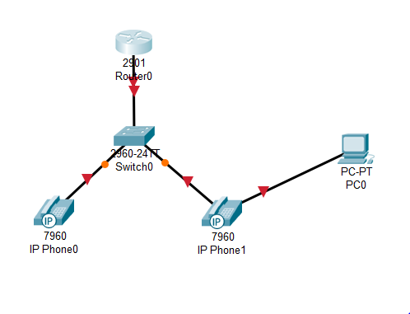

**R1 Configurations:**

en conf t

hostname R1

ntp master

ip dhcp pool Voice

network 172.16.0.0 255.255.255.0

default-router 172.16.0.1

option 150 ip 172.16.0.2

exit

ip dhcp pool Data

network 172.16.0.16 255.255.255.240

default-router 172.16.0.17

option 150 ip 172.16.0.2

exit

int G0/1

no shut

int G0/1.1

encapsulation dot1q 10

ip add 172.16.0.1 255.255.255.240

no shut

int g0/1.2

encapsulation dot1q 20

ip addr 172.16.0.17 255.255.255.240

exit

telephony-service

max-ephone 2

max-dn 2

ip source-address 172.16.0.2 port 2001

create cnf-files

exit

**S1 Configurations:**

en

config t

hostname S1

vlan 10

name Voice

vlan 20

name Data

int range fa0/3 - 4

switchport mode access

switchport voice vlan 10

switchport mode access

switchport access vlan 20

int fa0/20

switchport trunk encapsulation dot1q

switchport mode trunk

Snapshots:

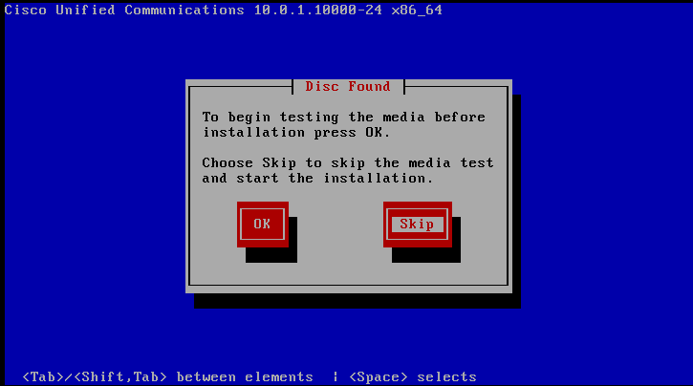

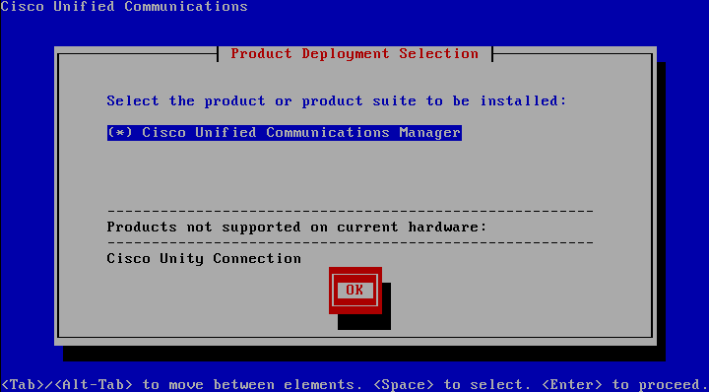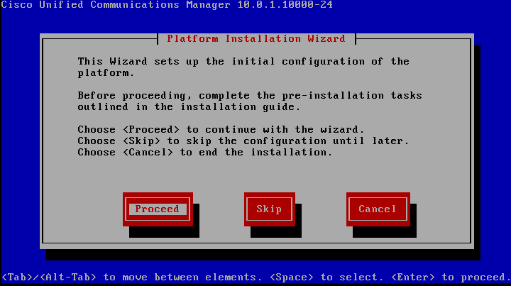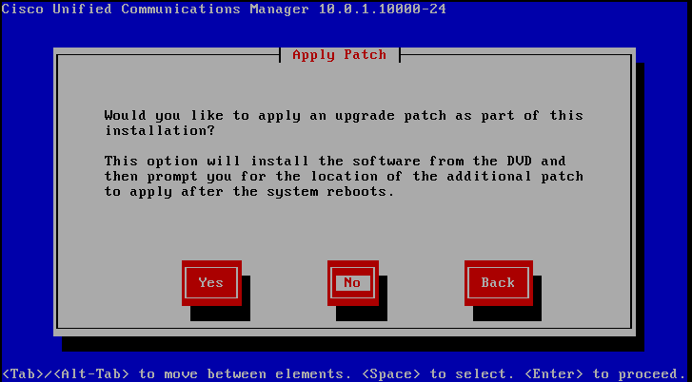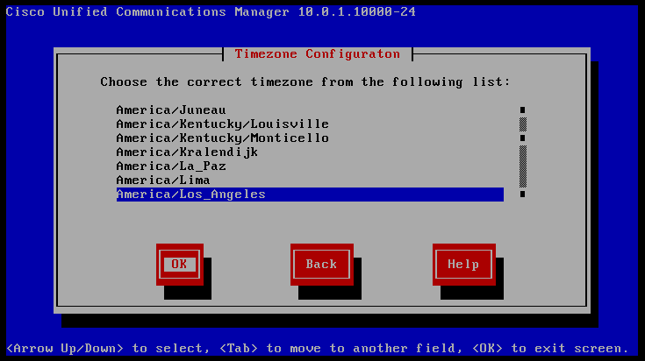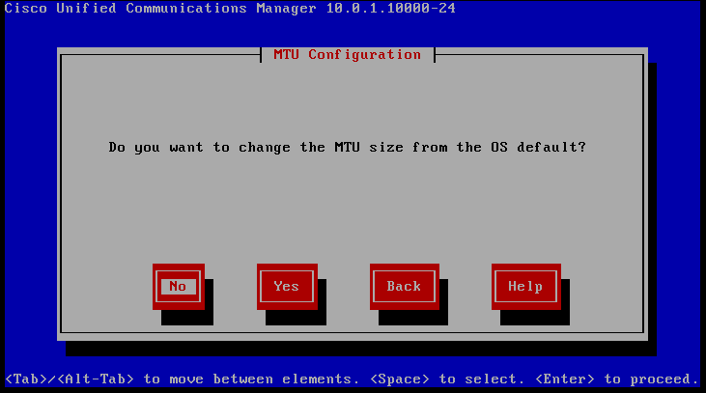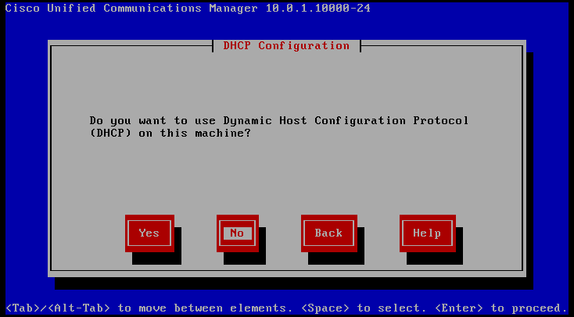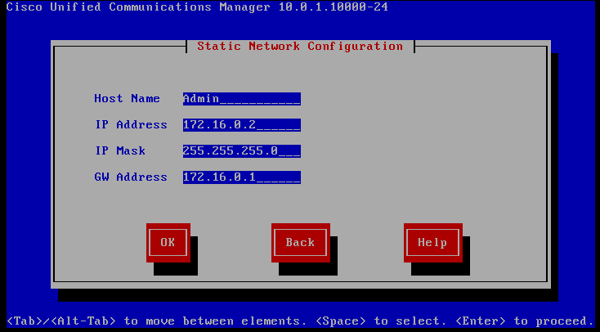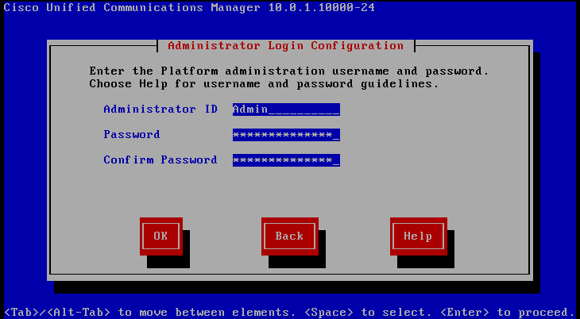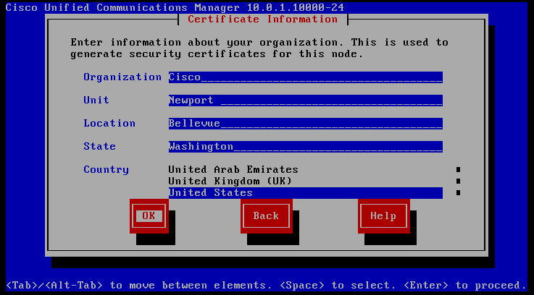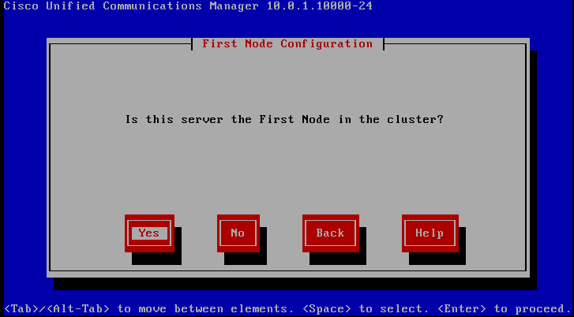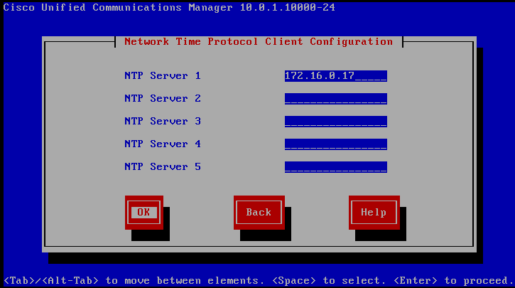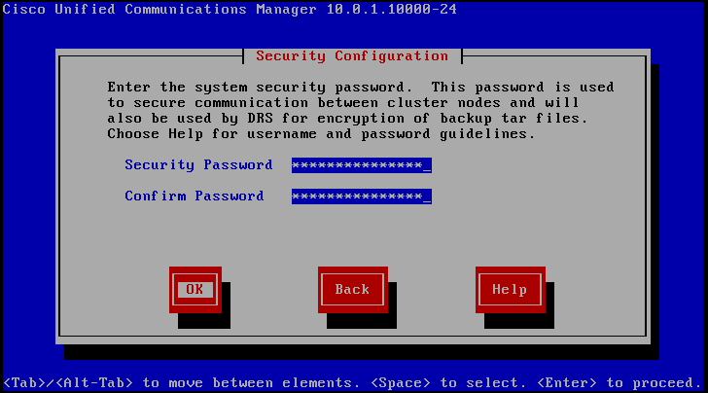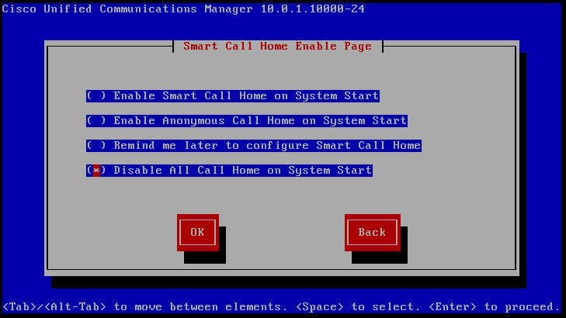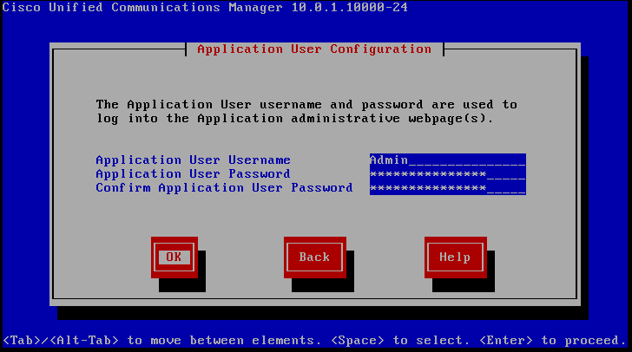

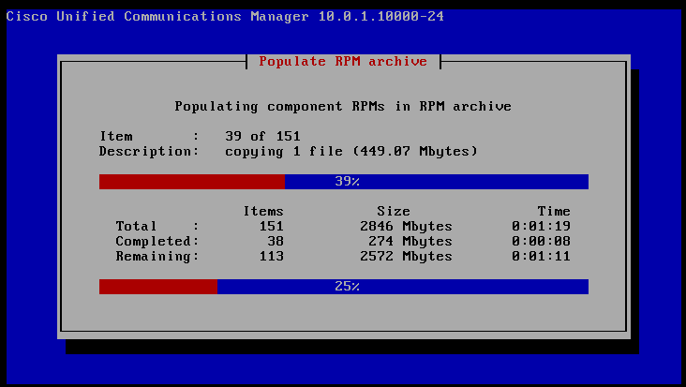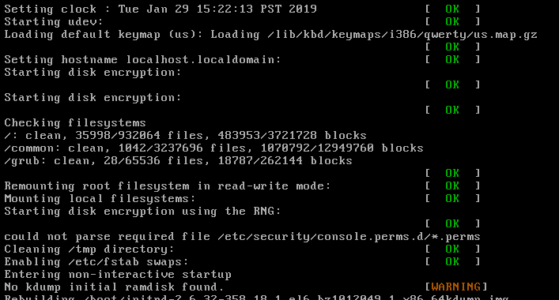



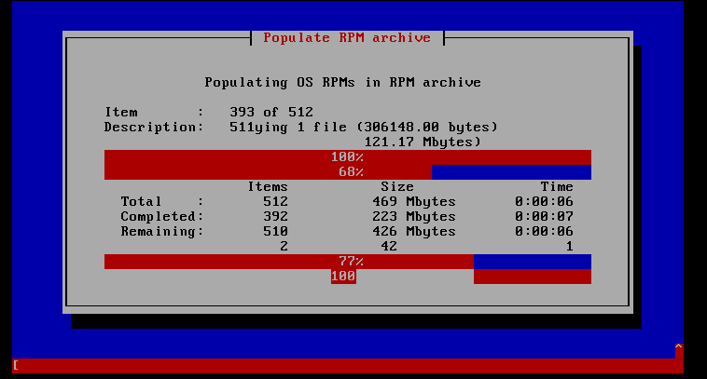

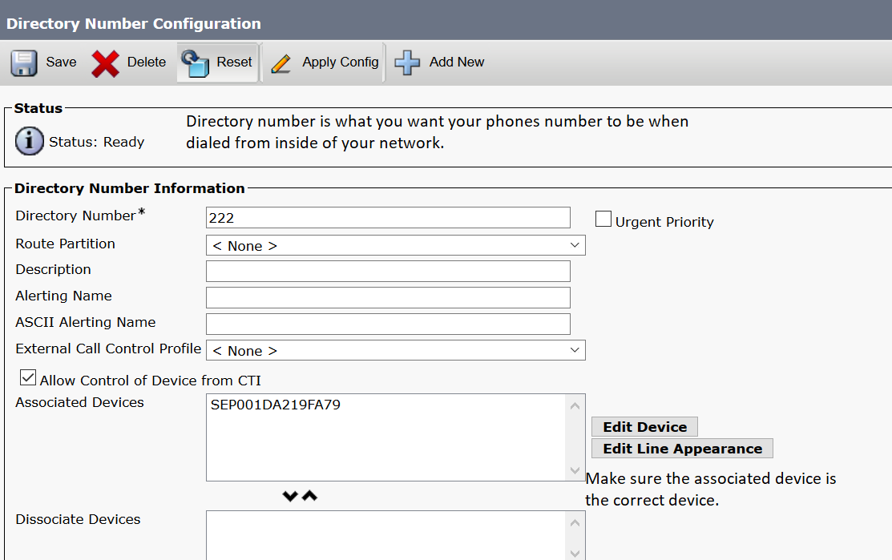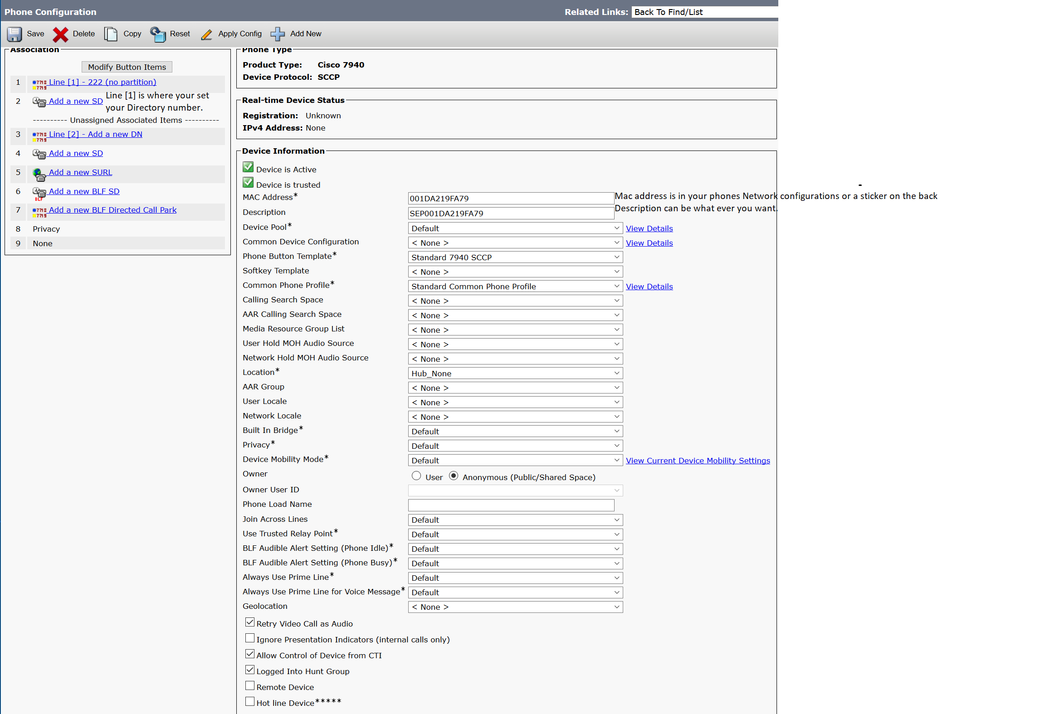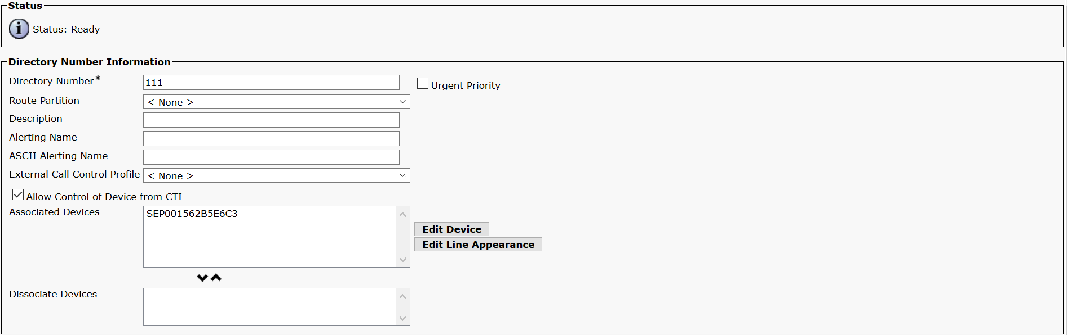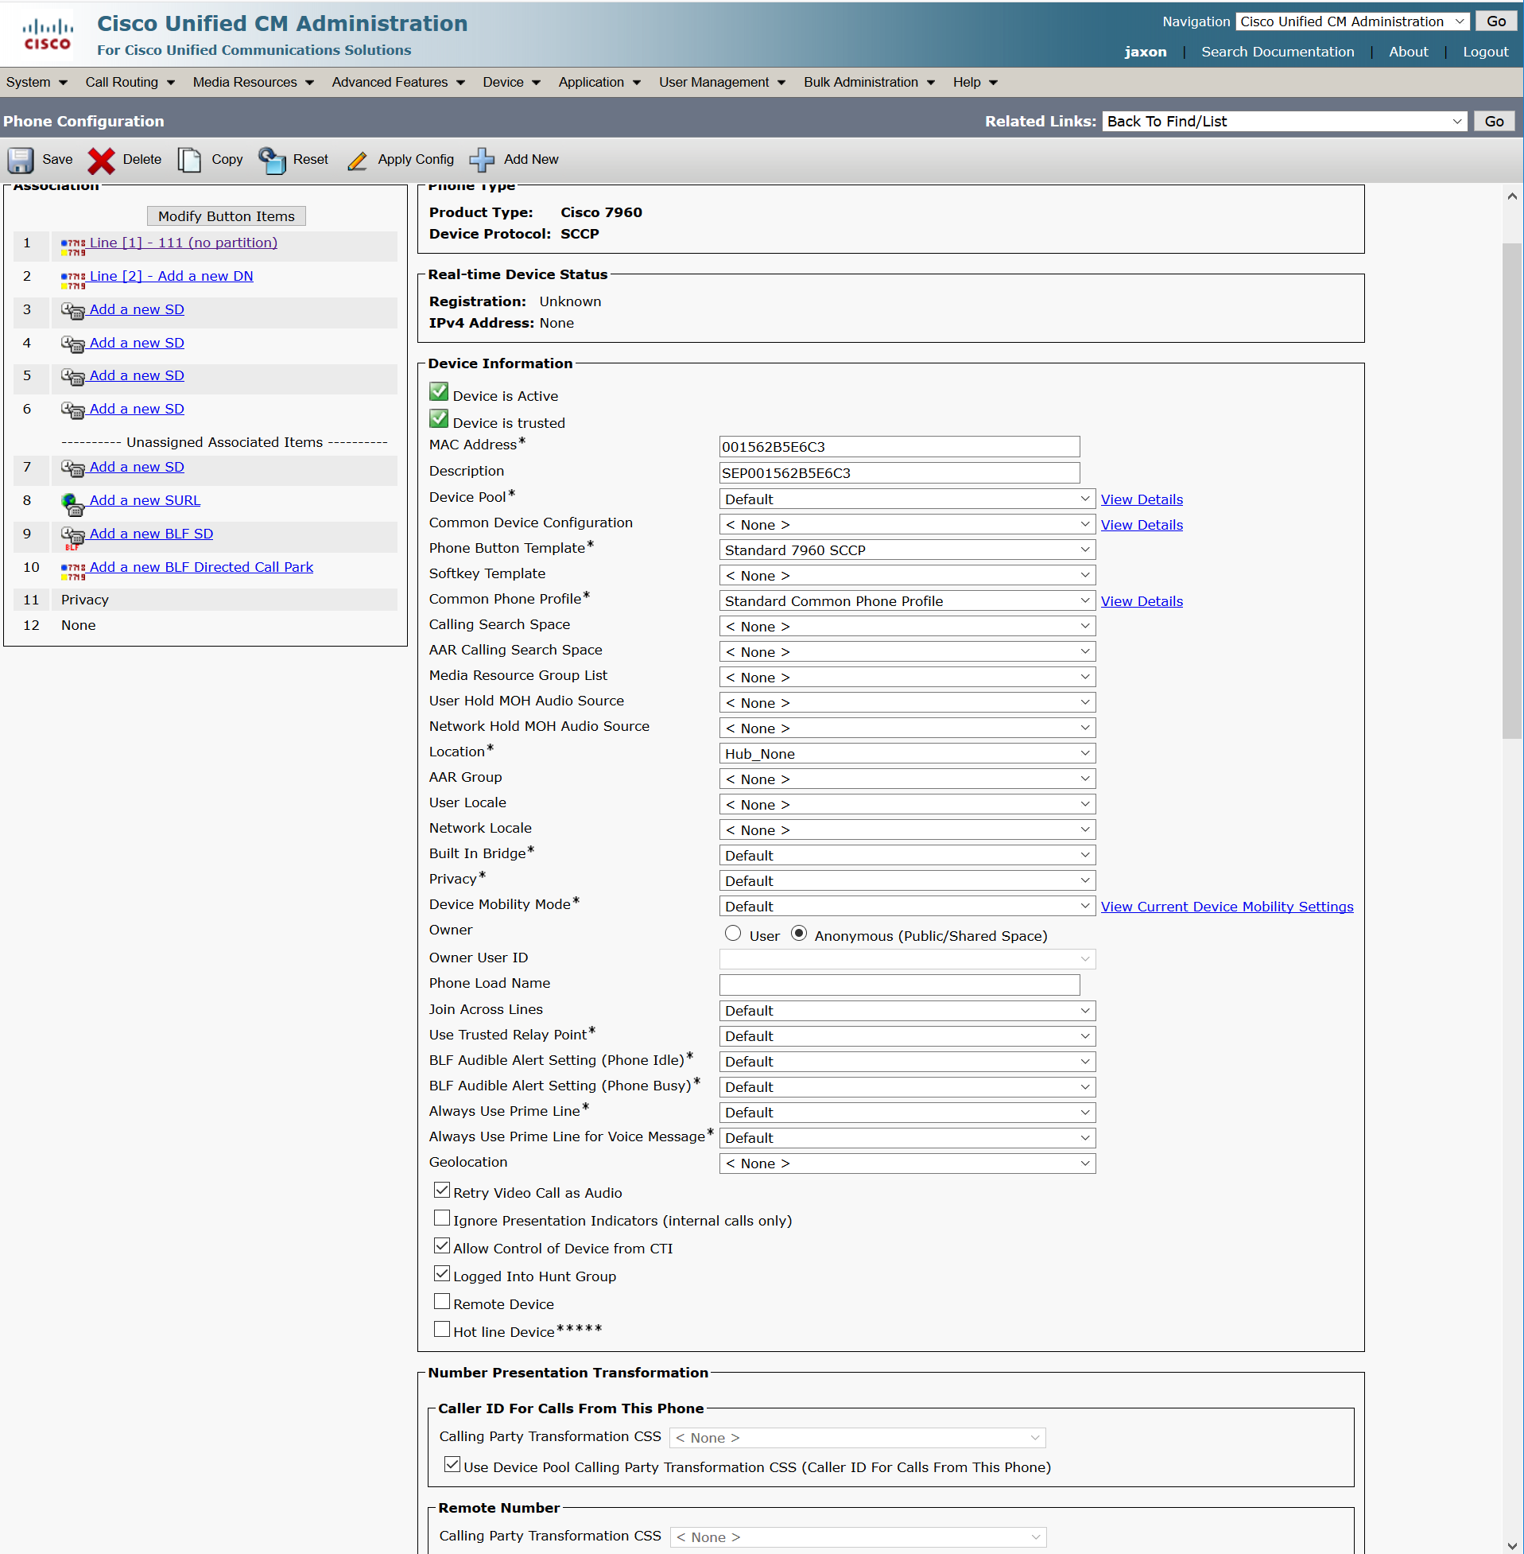

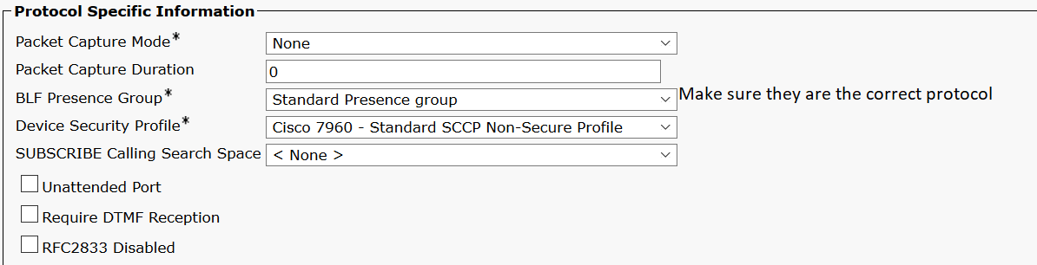

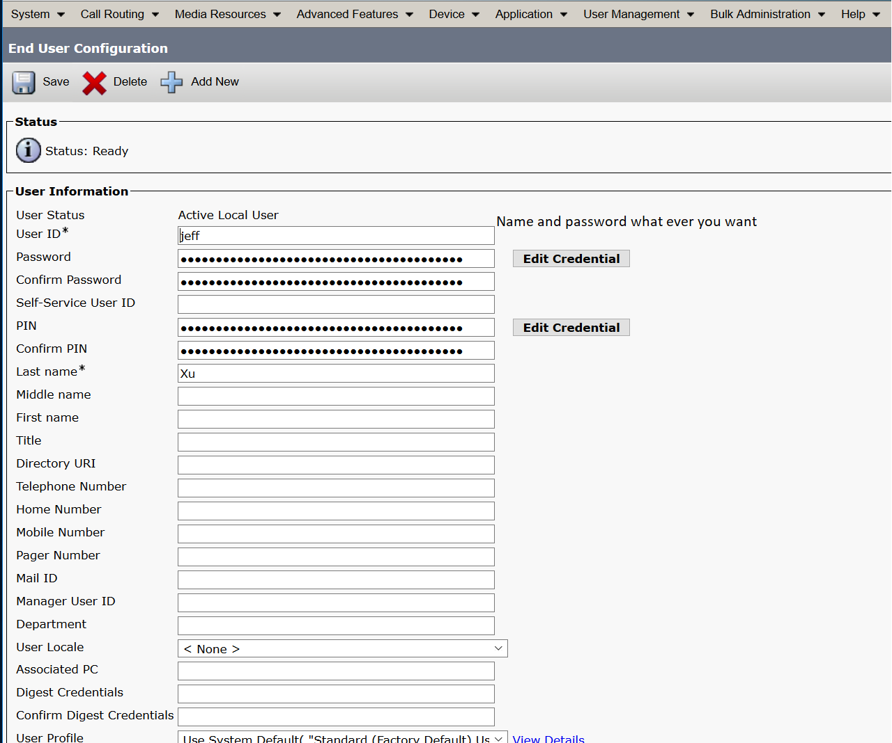

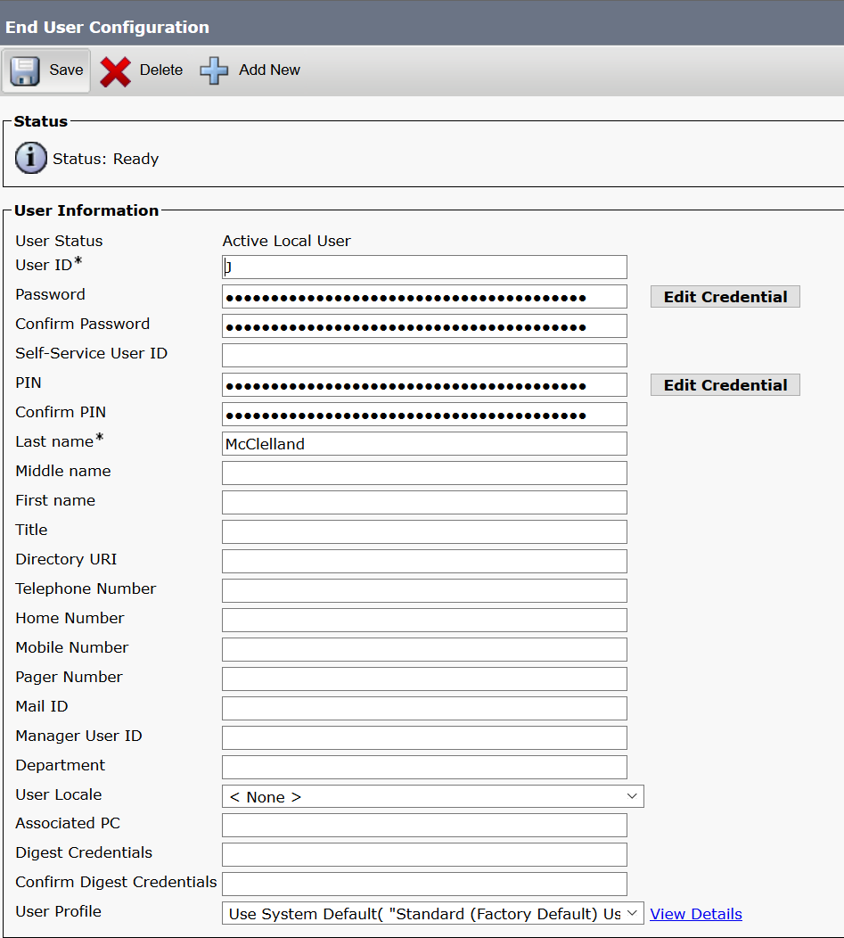

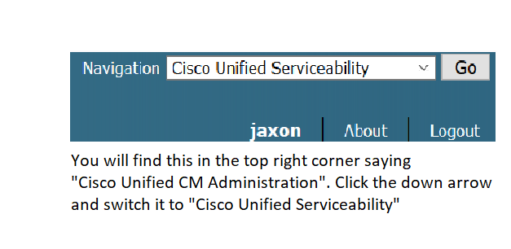

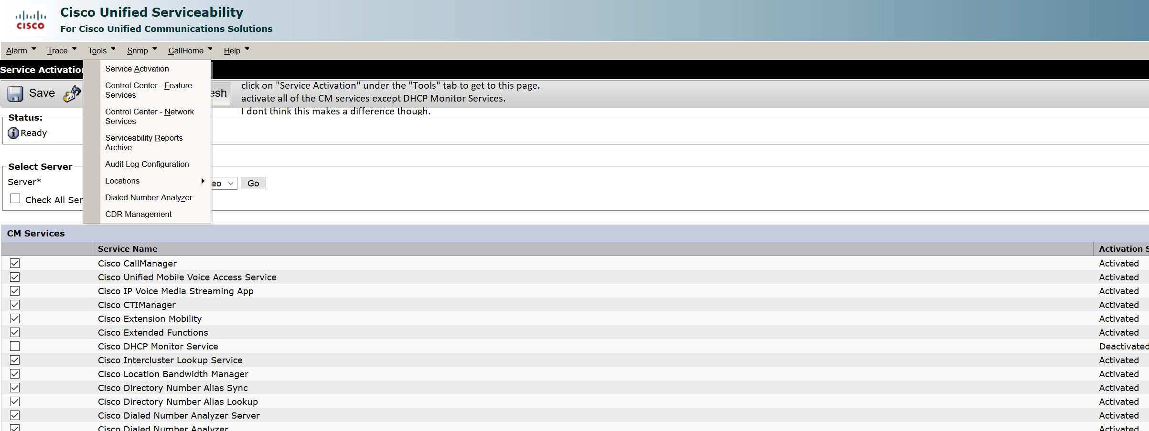

**Problems:**

Not too hard, we were able to finish it in 3 days, winning the bet. The only bumps we ran into were at the beginning where we had to go through the installation process and there were a few jargons we didn’t know that had to be filled correctly. And in the web GUI, it was just as confusing as ASDM, but there were a few Cisco guides we were able to research on to find the right places such as domain number and phone registrations.

**Conclusion:**

I feel like this is similar on how I started with ASAs and ASDM. First it was confusing where they placed everything and hidden everything without a proper guide, but after getting used to it, it gets pretty easy.